2019 Bell Choir Summer Camp!

WHAT: A chance to learn about English Handbells and learn to ring
in a bell choir.
WHEN: Monday 7/22 through Friday 7/26
WHERE: Eureka First United Methodist Church, at the corner of F and Del Norte streets.
WHO: Aspiring musicians! This camp is open to students and adults who want to try a
new instrument. We ask that students be at least 10 years old. Due to the short
time frame to prepare for our concert, a basic familiarity with reading music is necessary.

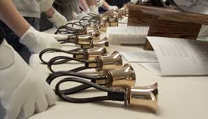
TIME: 9:00 am to 12:00 noon
ACTIVITIES: Campers will learn how to ring handbells, including various special techniques; we will play rhythm and music notation games; we will rehearse and prepare a musical program for families and friends; we will make new friends and share fun and laughter!!
THEME: Disney music is our theme this year. So grab your “ears”
and get ready for some fun!

CONCERT: Our culminating activity will be a summer bell choir concert on Friday evening, July 26, for family and friends. In addition to the summer camp ringers, the Bella Norte Bells will also be
performing a few numbers. The concert will be at 7:00 pm in the sanctuary.

*This bell choir camp is offered at no cost to attendees.

NEW THIS YEAR: The afternoon session for more advanced bell ringers will focus on learning some 12-bell pieces that we can then play at a senior center on Friday afternoon. We will also share our tunes at the concert.
Time of the afternoon sessions TBD, depending on interest.

RSVP: In order to plan music, etc, please contact Linda Dionne at 707.497.6554 or
408.406.3738 to make a reservation. Campers need to be able to attend all
5 days, as well as perform in the evening concert.

LET’S MAKE SOME BEAUTIFUL MUSIC!!

