First United Methodist Church Non-Profit Org.
520 Del Norte U.S. Postage
Eureka, CA 95501 PAID
Permit No. 44
Eureka, CA

RETURN SERVICE REQUESTED
The Messenger

Eureka First
United Methodist Church

August 2019

Rev. Kathryn Dunning, Pastor Office (707) 442-3015 Pastor’s Cell: (707) 599-2295
Email: grace520@pacbell.net Website: firstumceureka.org

From Pastor Kathryn…

“And serve each other according to the gift each person has received, as good managers of God’s diverse gifts.” 1 Peter 4:10

Dear Ones,

As I write this letter my heart is full of gratitude and love for the people of Eureka First United Methodist Church as I think about the diverse, gifted and generous ways you contribute to the well being and ministry of Eureka First UMC. There are many ways we serve in mission locally and throughout the world through your generous offerings and hands on work, but none of that would be possible if it weren’t for the countless hours you contribute to the care of the buildings and grounds, the support of worship and the preparing of meals. In other articles in this newsletter you will read about how in the month of July literally thousands of dollars worth of labor were contributed with no monetary compensation for the physical care of our facilities. You will also see articles inviting you to participate in new ways in worship and the kitchen. No one person can do all the work that needs to be done, but by everyone sharing their unique gifts of skills and service much has been and will be accomplished.
We have a paid nursery attendant, but we utilize volunteers for teaching Sunday School. I am so grateful for the generous and joyful collaboration between Jane Nelson and Galeladi Runningbrook for stepping forward to volunteer in this way.
I suppose I am especially mindful of volunteers and their contribution to the ongoing health and vitality of the church because of the recent move out of the area by the Flanders family. Kris, Ted, and Todd contributed many hours to decorating our sanctuary, ushering, greeting, putting out communion elements, preparing for and cooking and cleaning up after Second Sunday Breakfast. We knew it would take more than three people to “fill their shoes,” and some of us may have been a little nervous, wondering who would step forward, but we shouldn’t have been. I feel so grateful for the great response to requests to help in the kitchen and to serve in the many tasks required for worship. Please let us know if you are able to be part of the Kitchen or Worship teams on a regular, rotating or once in a while basis. Volunteer to teach Sunday School. Join others on the Second Saturday Work Days. They are wonderful ways of sharing our gifts and experiencing the joy of working with and serving others.
Working together, sharing our time and talents, we are the church. Thank You!

In Love,
Pastor Kathryn

Transformation at the Parsonage
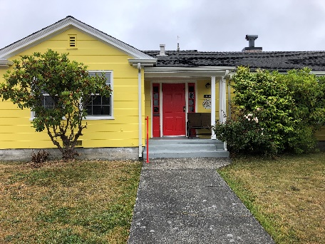
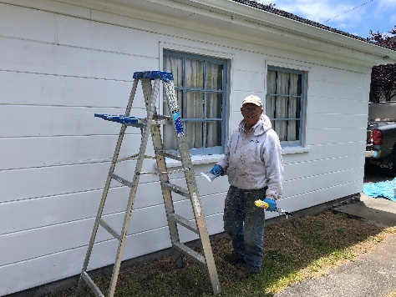
Have you noticed? Could you possibly have missed it? The parsonage is no longer white, but is now a cheery yellow with white trim and a red door. It all happened through the generous and expert work of volunteers Bill and Barb O’Brien. Bill and Barb spent 3 weeks prepping and painting the house with some help from painters Angela and Sarah Cameron and support efforts of Wayne Palmrose. Thank you for your generous donation of time and expertise!
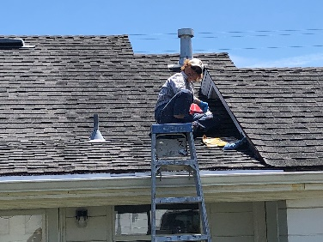

You may have also noticed another transformation at the parsonage with the installation of a privacy fence, something that will be a welcome addition for current and future residents. The new fence is possible because of the generous insurance pay out following a car being driven through the fence and into the back of the house in February.

Spring Into Summer Bible Study
Pastor Kathryn continues a Bible study on Paul’s first letter to the church at Corinth on Tuesdays at 7:00 PM and Wednesdays at 10:00 AM during the month of August. All are invited to this Bible study. A new study will begin in September.

We Are Invited!
The Wiyot Tribe, whose historic and ancestral land our church stands on, invites all to join them for Wiyot Day at their reservation on Table Bluff near Loleta on Saturday, August 24, 2019 from 2:00 PM to 10:00 PM. This is an opportunity for the whole community to come together and celebrate Wiyot Culture, honoring Elders and Veterans. The event features Dance and Cultural demonstration, Stick and Card Game tournament. Dinner is served at 5:30 PM for $10 a plate.

THANK YOU! To all the work day (plus) volunteers in July
Thank you to those who volunteered before, during and after our Second Saturday Work Day in July: Brad Mettam, Cookie Mahler, Pastor Kathryn and Rob Dunning, Margaret Stumpf, Wayne Palmrose, Brad Johnson, Dorothy Weber, Neil Ogimachi, Catherine Moore, Angela Cameron and Tim Lindow. And look at all they accomplished outside our buildings: pressure washed, pulled weeds, secured gutter drain pipe, mowed lawns, set post in parking lot in cement and stained crosses in front of memorial garden. See what was accomplished in and about our beautiful kitchen: coffee station cleaned, under sink shelf cleaned, bottom pantry shelves cleaned, microwave cleaned, hall counter by kitchen cleared, silver polished, towels washed, floor scrubbed. Other things accomplished inside: restocked First Aid Kit, installed Diaper Changing Station in accessible bathroom, patched hole in wall and installed a door stopper, sorted and donated unclaimed items, painted the storage cabinet in corner of the Fellowship Hall, cleaned nursery and other dusting and cleaning in Christie Hall.

Worship in the Redwoods

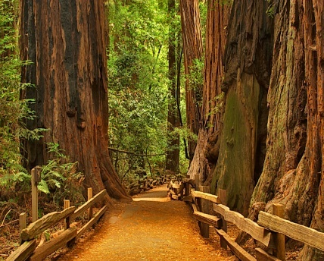
Join Us for Worship on Sunday Sep. 1
Grizzly Creek State Park
Worship 10:00 a.m.
Potluck Picnic Following Worship.

There will also be a 9:30 a.m. Worship Service at Eureka First
For many years Eureka First United Methodist Church has camped out at Grizzly Creek Redwoods State Park on Labor Day Weekend. Participants choose to come for all or a portion of the weekend. Some folks camp from Friday to Monday, but others for shorter periods of time. Grizzly Creek State Park has miles of hiking trails and the Van Duzen River provides a place for relaxing, wading, swimming, skipping rocks and Sunday morning baptisms. Organized activities include a potluck dinner on Saturday evening followed by singing around the campfire and Sunday morning worship at 10:00 AM followed by a potluck lunch. (There is also a 9:30 AM worship service in Eureka at the church)

Camping is in your own tent or RV and this year Eureka FUMC has again reserved the group site near the campground entrance. This group site will accommodate up to 40 persons and 8 vehicles. Cost per person to share the group site is $5 per person per night (maximum $15 per family per night) and includes 1 vehicle per family. Please let the church office (442-3015) know if you want to share the group site and how many of your family will be camping.

If you wish to have your own campsite, reservations need to me made at reservecalifornia.com.

If you plan to come for worship on Sunday morning, just let the Park Staff know when you enter the park that you are with the UMC and the church will pay your day use fee. Grizzly Creek State Park is located about 20 miles east of Hwy 101 on Hwy 36 and is about a 50 minute drive from Eureka. For more information, please contact the church office.

Sound and Video opportunity Are you interested in learning something new? Do you want to have our own reserved seat in church? Do you want to give Brad a break from time to time? Consider becoming a part of the sound and video team. If you are interested in seeing what this is all about, please leave a message with the church office.

Worship Team
There are many volunteer tasks required for worship including the volunteer musicians and singers who serve with our paid musicians, scripture readers, communion stewards and servers, ushers, greeters, and acolytes.
We have a new approach to providing ushers, greeters, acolytes and communion stewards for each Sunday morning worship service. We are utilizing a group of four volunteers on a rotating basis to cover all of these responsibilities. There is a written job description posted on the bulletin board near the sanctuary entrance, and copies are available from the office. All four persons serve as ushers, collecting the offering and at least one person serves as a greeter at the front doors and one in Wesley Chapel. One of the four serves as the acolyte, lighting and extinguishing the candles and one puts out the communion elements and cleans them up after. Thank you to Gail Johnson who is picking up the bread each Saturday afternoon and placing in the church refrigerator to be ready for Sunday morning. Currently coordination of these volunteers is being done through the church office, but we are grateful to Dorothy Weber who has volunteered to coordinate these folks going forward. We are also grateful for Pat Reimonenq who is coordinating decorating the sanctuary and Angela Cameron, currently coordinating flowers. Please let the church office know if you would like to serve in some capacity on the worship team.
Kitchen Team
Thank you to Pam Coen, who is heading up the coordination of our Kitchen Team, and to all those who are helping in a variety of ways in the Kitchen. Our July Second Sunday Breakfast Team did an outstanding job of serving church folks and our guests. Thank you Pam, Rich, Bobby, Brian, Catherine and Brad. And thank you for all the kitchen “elves” noticing things that need to be cleaned and organized and then doing it, and for those who are stepping up to help with Third Saturday Supper. Please let the office know if you can be part of our Kitchen Team in any way.

Second Saturday Work Days
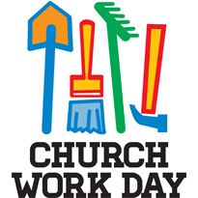
On Saturday, August 10, from 9:00 to 1:00, the Board of Trustees invites the whole church to come together to do the varied tasks of cleaning, sorting, and fixing that keep our church buildings and grounds in good shape. There are inside and outside tasks for everyone to do. Lunch is served to all the workers at noon.

Sunday August 11th
SECOND SUNDAY BREAKFAST
8:30 a.m. to 9:30 a.m.
In Fellowship Hall
Everyone’s welcome!
Free will offering ($5 suggested donation) to cover expenses

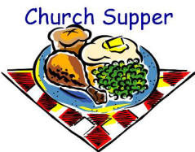
Third Saturday Supper!
On Saturday, August 17th at 5:30 PM you are all invited to Third Saturday Supper at Eureka First UMC. Dinner will be served at 5:30. The meal will conclude by 6:30 and be followed by cleanup by volunteers present and board games or other fellowship activities for those who wish to stay until 8 or 8:30. This will be a good time of food, faith and fun for all!

Women’s Book Club
The Sisters of Charlotte Literary & Teatime Society will meet Tuesday, August 20th at 3:30 p.m. in the Library. The book is Our Kind of Traitor by John le Carré. The hostess is Pam Coen.
Church Family News

Rev. Charles Smith, currently the pastor at Turlock UMC and formerly at Eureka First UMC from 1996-2006, is being treated for a rare form of abdominal cancer. He reports that his prognosis is now good, that he is working at the church and feeling well as he continues treatment every other week at a Cancer Center in Phoenix, Arizona. Please hold him and his medical team in your prayers. If you wish to send him a greeting his address is 1660 Arbor Way, Turlock, CA 95380.

The Flanders family have safely traveled across the country to Virginia. We have received word that Todd has begun a new job and that Ted and Kris are actively house shopping. Continue to keep them in your prayers as they make this transition.

Please hold the following persons in prayer:
Gail Johnson
Silas Morrison at Frye’s Care Home in Cutten
Neal Sligh
Jane Nelson’s 3 year old grandnephew, Rhett
Michele Montgomery, recently hospitalized
Cory Cassevah, son of Sedona Bowser
Joshua Ruch, a young man dealing with depression.

Art Lewis Diane Mettam
Ralph Nelson Sadiki Koo’s
Aaron White and family Bev Strubinger
Nancy Quintrell Shirley Peterson
Galeladi Runningbrook Vis Upatisringa
Marty Johnson Jonathan O’Keefe
The O’Keefe family Wayne Palmrose
Mark McKinney Irene Hedgecock

August Birthdays
1 Daniel Ryan 16 Ted Flanders
1 Peggy Hobbs-Suchar 20 Don Quintrell
2 Melysha Ngiraibiochel 24 Sean Woodburn
4 Dona Pomeroy 24 Rosemary Landry
7 Garry Tucker 27 Dottie Reynolds
10 Jason Bowser 27 Herb Pierce
11 Matthew Taylor 28 Stasia Young
14 Joan Romo 29 Connie Ross
14 Tami Davies-Hughes

August Anniversaries
8 Jason & Sedona Bowser 17 Bev & Rich Strubinger
11 Dottie & Bill Reynolds 28 David & Joyce Hayes
14 Jill & Tony Kimura

Congratulations!-- If we missed your special day
or have the incorrect date please call the church office
so we can get it right next year.

Financial Summary

June 2019
General Fund Revenue: $14,499.41 General Fund Expense: $16,446.82

2019YTD (June 30)
2019 General Fund Revenue: $85,840.54
2019 General Fund Expense: $94,690.45
+- --8,849.91

Thank you for your generous giving to God through the church.

July Worship Attendance
July 7 Total – 73
July 14 Total – 75
July 21 Total – 67
July 28 Total – 62

Tie Dye T-shirts for sale
A friend of Dorothy Weber is offering tie dye shirts for sale. The shirt has a large heart with large cross in center. Entire shirt is tie dyed! It’s $60 for one shirt, or $50 each for an order of a dozen or more. Dorothy will place an order on September 1. 50% deposit needed per order. Sizes over XLG might be a little extra. Call Dorothy 707 502 4445.

MUSIC AT EUREKA FIRST
Praise Band
Would you like to sing or play an instrument with the worship team? Join us for rehearsals on Tuesdays at 7 p.m.

We rehearse on Wednesdays at 7, working on new music for the upcoming year.

Summer Bell Camp was an amazing success this year! Under the direction of Linda Dionne, a diverse group of new and returning campers started on Monday with a clean slate, learned bell techniques and a variety of Disney tunes, and presented them in concert to a full house that same Friday!

Bell Campers and the Bella Norte Bells
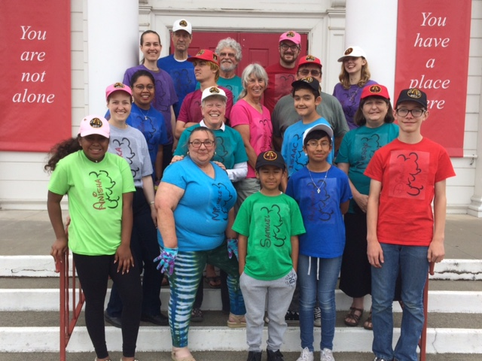

M I S S I O N S
Disaster Recovery Mission Team to Lake County
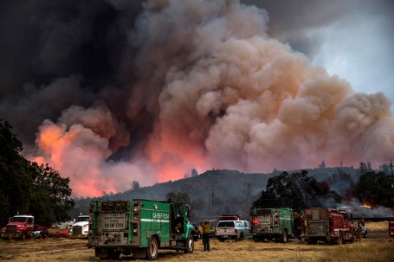
The Clear Lake area has experienced several devastating wildfires over the past few years. In the fall of 2016 and again in 2018 Eureka First UMC sent a team to help in the recovery by working with Hope City on new homes being constructed there. In 2019 the work is not yet finished and so we will return to Middletown this October to work on ongoing projects there. Team members need to be persons with a willingness to give of their time and effort to help others. No special skills are required. Dates of the trip are Sunday, October 6 through Friday, October 11. We will be staying in a dormitory in Middletown, but there are also spaces with hookups for RVs on site. The cost for registration, housing and food is $150, but Eureka First UMC’s Mission Committee will pay up to half of that, so we ask that each person provide their own transportation and at least $75 toward the cost of the trip. There are also scholarships available for those who might need extra assistance. While we go to help others in need, those who participate in these disaster relief trips always receive many blessings. Please consider being a part of this 2019 Disaster Relief Mission Team to Lake County California. To get more information and to sign up to be a part of the team, please contact Pastor Kathryn (707) 599-2295 or Pam Coen (707) 496-4424.

DRUMM STICK SUNDAY 8/11
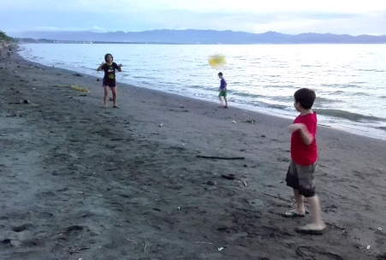
The Drumms are in South Asia! As their home church we raise funds to support their project. One Sunday a month we sell DRUMM STICKS (ice cream cones) -- $2 each. So, treat yourself to ice cream and support this exciting project.

Upcoming Mission Events

African Handcraft Sale Nov 10 and Nov 17

Christmas Prison Ministry gifts for children who have an incarcerated parents

Luci Lights to Gaza—making a difference
Your birthday and anniversary pennies are going to purchase Luci lights to help the people in Gaza during blackouts. And they are making a big difference in people’s lives!

Food Donations for July–122 pounds!
Food placed in the basket in the narthex is distributed to the Food Bank, the Rescue Mission or kept in the church office for people who fall between the cracks of services available. Food is weighed by our children on the first Sunday of each month. Our goal is to collect one hundred pounds of food each month.
Food Donations will be weighed on Sunday July 7.
Submissions to the Messenger
If you have anything you would like included in the Messenger, please sent submissions directly to your friendly editor, Dan Dionne, at editor@firstumceureka.org. Note the new email address!

