First United Methodist Church Non-Profit Org.
520 Del Norte U.S. Postage
Eureka, CA 95501 PAID
Permit No. 44
Eureka, CA

RETURN SERVICE REQUESTED
The Messenger

Eureka First
United Methodist Church

September 2019

Rev. Kathryn Dunning, Pastor Office (707) 442-3015 Pastor’s Cell: (707) 599-2295
Email: grace520@pacbell.net Website: firstumceureka.org

From Pastor Kathryn…

“For God shows no partiality.” Romans 2:11

Dear Ones,
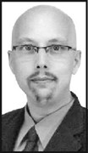
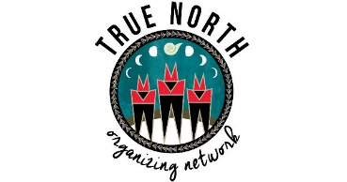
In 2014 a stranger came a to our worship service on Sunday morning. He was clean and well dressed with a jacket and tie, but his roller bag suitcase gave him away as someone without permanent housing. I, and many of you, greeted him and over the next months and years we got to know a lot of the story of his life. Charles Edward Smith, known to us as Charlie, was born and raised in Humboldt County. He served in the US Navy, and attended College of the Redwoods following his time in the Navy. During his college years Charlie was diagnosed with non-Hodgkin Lymphoma for which he received life-saving medical treatment that enabled him to live for more than 20 years, many of them in Thailand where he worked as an English teacher. Because of an unstable political situation in Thailand, he returned to live in Eureka in 2014. After his return to Humboldt County he was never able to find permanent housing or regular work. Side affects of the life saving treatment he had received years earlier caused disabilities that made him unable to hold a job and would ultimately lead to complications that contributed to his death at St. Joseph’s Hospital in Eureka on August 27, 2017 at the age of 49. At the time of his death I was helping Charlie appeal the denial he had received for Social Security disability benefits, and he was among those we call “homeless” in Eureka, one who many look down on as having less value than others, but as Paul said in his letter to the church at Rome, “God shows no partiality,” and this church fully welcomed Charlie as a member and when he died with no resources we paid for his cremation costs and arranged for his burial in the Northern California Veterans Cemetery in Igo, near Redding where my husband Rob and I attended the burial of his remains in the fall of 2017.
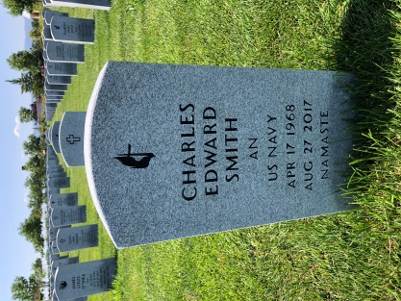
On our way home from a week’s vacation last month Rob and I made a detour to see the marker on Charlie’s grave. It touched me deeply to see that though in life Charlie died with less than many, in death the marker over his grave is just like that of all the other veterans buried there regardless of rank or material success. The marker bears the United Methodist cross and flame signifying his membership in this part of the Christian family and the word Namaste, a word that in Hinduism accompanies a gesture of bowing with hands pressed together, fingers pointing upwards and means, “I bow to the divine in you.” Charlie was a loving, gentle soul who saw the light of God in all he encountered, as he greeted them with hands pressed together and the word Namaste.
On this second anniversary of the death of Charles Edward Smith may we hold his memory in our hearts and commit our lives to following in the way of Jesus who called us to love all without showing partiality.

In Love,
Pastor Kathryn

An Invitation to BELONG
True North Organizing Network invites all interested persons to a Regional Leadership Assembly on Saturday September 7, from 1:00 to 4:30 PM at the Orick Community Hall. Reverend Ben McBride, Co-Director of PICO California, will be our guest presenter and trainer as we launch Belong Circles in our region. Belong Circles are a way of joining with others in small groups to grow in our understanding of how we belong to each other, how to bridge across difference, and how to harness that sense of belonging as shared power to organize for the betterment of our communities. Pastor Kathryn will be leading a four-week small group experience based on the Belong Circles beginning in mid October. Come learn about this statewide initiative and join together with True North folks from throughout Del Norte, Humboldt and Tribal Lands on September 7. The day’s program will conclude with a shared dinner at 4:00. For more information or to participate in carpooling to Orick please contact the church office or Pastor Kathryn.

Spring Into Summer Bible Study
Pastor Kathryn continues a Bible study on Paul’s first letter to the church at Corinth on Tuesdays at 7:00 PM and Wednesdays at 10:00 AM that will conclude the first week in September (September 3 and 4th) There will be a new study beginning in mid October.

Reserve your place at the table for the Redwood Adult and Teen Challenge Fund Raising Banquet
Eureka First UMC has a history of supporting Redwood Adult and Teen Challenge, a Christian Drug and Alcohol Rehabilitation program that helps women and men get back on paths to full living after living lives of addiction. We are invited to A Night of Hope, fund raising banquet on Thursday, September 12, 2019 from 5:30 to 8:30 PM at the Sequoia Conference Center on Myrtle Ave. EFUMC’s Mission Committee has a purchased a table for 8 for this tri-tip dinner that will feature music by the Redwood Adult and Teen Challenge Choir, testimonies, guest speaker Dennis Gaxiola and a silent auction. To have a place at Eureka First UMC’s table all you have to do is be one of the first 8 people to respond to this invitation and come prepared to be inspired, and maybe buy something at the silent auction. Just call the church office, or let us know via your attendance slip on Sunday morning that you would like a place at the table.

Budget Requests
If you have a request for the 2020 church budget, please submit it to the church office during the month of September so that all requests may be taken into consideration as we plan for the best stewardship of the resources entrusted to us.
Remember that if you don’t get your request in, the church can’t budget any money for your program!

Children’s Trust Fund Expanding Miracle Funds
In 1992 Almost Home, an after school day care program of Eureka First United Methodist Church closed. At that time there was $975.78 remaining in Almost Home’s funds and with that the Children’s Trust Fund was established. It was eventually decided by the church to use the funds for College Scholarships and special needs in Children’s Ministry $12,740 in College Scholarships and nearly $6,000 for various needs of children’s ministry. The Children’s Trust Fund committee as agreed to award two $500 scholarships to two very deserving recipients this year: Brook Hansen who is attending College of the Redwoods with plans to be a music major and Seren Davies-Hughes who has begun Kinesiology studies at Chico State. Please consider making a special donation marked Children’s Trust Fund to replenish and grow this source of significant support and ministry for our church.

Sound and Video opportunity
Are you interested in learning something new? Do you want to have our own reserved seat in church? Do you want to give Brad a break from time to time? Consider becoming a part of the sound and video team. If you are interested in seeing what this is all about, please leave a message with the church office.
THANK YOU! To all the work day (plus) volunteers in August
Thank you to those who volunteered on our Second Saturday Work Day in August: Brad Mettam, Cookie Mahler, Pastor Kathryn, Brad Johnson, Dorothy Weber, Pam Coen, Sadiki Koo’s, Ralph Davis, Joan Brady, Carol Dianich, Chad Rechelluul, CJ Rechelluul and Tim Lindow. And look at all they accomplished outside and inside our buildings: pulled weeds, tidied surfaces in kitchen, cleaned stainless steel drawer fronts and doors, cleaned refrigerator, check supplies in first aid kit, picked up trash, touched up paint in hall, cleared off upper shelf in narthex, arranged front pews to accommodate wheel chairs, touched up some paint on pews, repaired rain down spout drain by the office, put weight room in order in Christie Hall, sorted stuff for people to claim and fed the workers. THANK YOU!

Worship in the Redwoods

Join Us for Worship on Sunday Sep. 1
Grizzly Creek State Park
Worship 10:00 a.m.
Potluck Picnic Following Worship.

There will also be a 9:30 a.m. Worship Service at Eureka First
Don’t miss out on our church’s annual campout at Grizzly Creek Redwoods State Park this weekend, August 30 – September 2. Come for all or a portion of the weekend. Grizzly Creek State Park has miles of hiking trails and the Van Duzen River provides a place for relaxing, wading, swimming, skipping rocks and Sunday morning baptisms. Organized activities include a potluck dinner on Saturday evening followed by singing around the campfire and Sunday morning worship at 10:00 AM followed by a potluck lunch. (There is also a 9:30 AM worship service in Eureka at the church)
Eureka First UMC has reserved the group site near the campground entrance for Friday, Saturday and Sunday nights, August 30 – September 3. Cost per person to share the group site is $5 per person per night (maximum $15 per family per night) and includes 1 vehicle per family. Camping is in your own tent or RV.
If you plan to come for worship on Sunday morning, just let the Park Staff know when you enter the park that you are with the UMC and the church will pay your day use fee. Grizzly Creek State Park is located about 20 miles east of Hwy 101 on Hwy 36 and is about a 50 minute drive from Eureka. For more information, please contact Pastor Kathryn (707) 599-2295

Volunteer Opportunities

Second Sunday Breakfast Volunteers Needed
Our Second Sunday Breakfast will continue in September with a ham/egg/potato menu. The kitchen crew will be working hard to be sure that you can all enjoy a filling breakfast and some fellowship before service.

Kitchen Team
The kitchen crew would also like to seek and find a few more volunteers to help serve and clean up on our breakfast days. Please contact the church office or Pam Coen (707-496-4424)if you are being led to serve in this way..

Sunday September 8th
SECOND SUNDAY BREAKFAST
8:30 a.m. to 9:30 a.m.
In Fellowship Hall
Everyone’s welcome!
Free will offering ($5 suggested donation) to cover expenses

Second Saturday Work Days
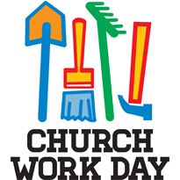
On Saturday, September 14, from 9:00 to 1:00, the Board of Trustees invites the whole church to come together to do the varied tasks of cleaning, sorting, and fixing that keep our church buildings and grounds in good shape. There are inside and outside tasks for everyone to do. Lunch is served to all the workers at noon.

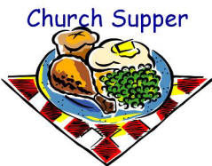
Third Saturday Supper!
On Saturday, September 21st at 5:30 PM you are all invited to Third Saturday Supper at Eureka First UMC. Dinner will be served at 5:30. The meal will conclude by 6:30 and be followed by cleanup by volunteers present and board games or other fellowship activities for those who wish to stay until 8 or 8:30. This will be a good time of food, faith and fun for all!

Women’s Book Club
The Sisters of Charlotte Literary and Teatime Society (otherwise known as the Book Club) continues to meet monthly and enjoy lively discussion of the books we read. The next meeting will be held on September 17 at 3:30. This month’s book is “A Thousnad White Women” and our meeting will be hosted by Galeladi Runningbrook. Octobers book is “What Happened?”. Please join us if you can!

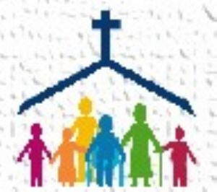
Church Family News

Congratulations on the birth of Finnley Grey Spangler born August 9, 2019 in San Diego to parents Chloe (Lindow) and Chris Spangler. Finnley was also welcomed by big brother Luca. His proud grandparents are Tim and Kerra Lindow.

Please hold the following persons in prayer:
Michele Montgomery who was recently hospitalized at Stanford
Galeladi Runningbrook having surgery on August 28

Sharon Sligh who suffered a nasty fall recently.
Neal Sligh
Shirley Peterson experiencing severe back pain
Gail Johnson
Silas Morrison at Frye’s Care Home in Cutten
Jane Nelson’s 3 year old grandnephew, Rhett
Cory Cassevah, son of Sedona Bowser
Joshua Ruch, a young man dealing with depression.
Art Lewis
Diane Mettam
Ralph Nelson
Sadiki Koo’s
Aaron White and family
Bev Strubinger
Nancy Quintrell
Vis Upatisringa
Marty Johnson
Jonathan O’Keefe
The O’Keefe family
Wayne Palmrose
Mark McKinney
Irene Hedgecock

September Birthdays
2 Mark McKinney 18 CJ Rechelluul
2 Vis Upatisringa 23 Mickey Harris
3 Sheryl Brekke 23 Sally Pierce
4 Katie Coventry 24 Heidi Benzonelli
5 Lily-Anne Span 25 JoAnn Newquist
6 Forrest Vance 26 Paula Blackshear
9 Galeladi Runningbrook 27 Art Lewis
10 Lacy Ross 27 Nakiah Taylor
11 Raven McAdams 27 Gregory Holtz
12 Sharon Dillon 29 Kieran Powers
14 Sandra Weyer 29 Charles Young
17 Bentley Hughes 30 Cheryl Churchill

September Anniversaries
7 David & Peggy Suchar
8 David & Sonia Samelson
23 Louis and Paula Amato
27 John & Sara Lundstrom

Congratulations!-- If we missed your special day
or have the incorrect date please call the church office
so we can get it right next year.
♥ ♥ ♥ ♥ ♥

Financial Summary

July 2019
General Fund Revenue: $16,391.28 General Fund Expense: $14,799.36

YTD 2019(July 31)
2019 General Fund Revenue: $102,231.82
2019 General Fund Expense: $109,489.81
+- --7,257.99

Thank you for your generous giving to God through the church.

August Worship Attendance
August 4 Total – 60
August 11 Total – 60
August 18 Total – 60
August 25 Total – 62

Tie Dye T-shirts for sale
A friend of Dorothy Weber is offering tie dye shirts for sale. The shirt has a large heart with large cross in center. Entire shirt is tie dyed! It’s $60 for one shirt, or $50 each for an order of a dozen or more. Dorothy will place an order on or about September 1. 50% deposit needed per order. Sizes over XLG might be a little extra. Call Dorothy 707 502 4445.

MUSIC AT EUREKA FIRST
Praise Band
Would you like to sing or play an instrument with the worship team? Join us for rehearsals on Tuesdays at 7 p.m.

We rehearse on Wednesdays at 7, working on new music for the upcoming year. This fall, we will once again attend the Redding Handbell Festival in October. We will also begin working on an ambitious repertoire for the holidays.

M I S S I O N S
Disaster Recovery Mission Team to Lake County
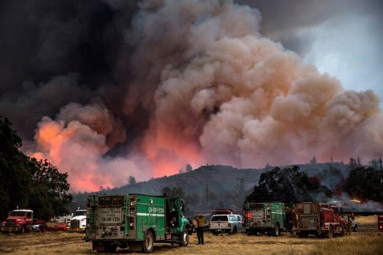
The Clear Lake area has experienced several devastating wildfires over the past few years. In the fall of 2016 and again in 2018 Eureka First UMC sent a team to help in the recovery by working with Hope City on new homes being constructed there. In 2019 the work is not yet finished and so we will return to Middletown this October to work on ongoing projects there. Team members need to be persons with a willingness to give of their time and effort to help others. No special skills are required. Dates of the trip are Sunday, October 6 through Friday, October 11. We will be staying in a dormitory in Middletown, but there are also spaces with hookups for RVs on site. The cost for registration, housing and food is $150, but Eureka First UMC’s Mission Committee will pay up to half of that, so we ask that each person provide their own transportation and at least $75 toward the cost of the trip. There are also scholarships available for those who might need extra assistance. While we go to help others in need, those who participate in these disaster relief trips always receive many blessings. Please consider being a part of this 2019 Disaster Relief Mission Team to Lake County California. To get more information and to sign up to be a part of the team, please contact Pastor Kathryn (707) 599-2295 or Pam Coen (707) 496-4424.

DRUMM STICK SUNDAY 8/11
The Drumms are in South Asia! As their home church we raise funds to support their project. One Sunday a month we sell DRUMM STICKS (ice cream cones) -- $2 each. So, treat yourself to ice cream and support this exciting project.

Upcoming Mission Events

African Handcraft Sale Nov 10 and Nov 17

Christmas Prison Ministry gifts for children who have an incarcerated parents

Luci Lights to Gaza—making a difference
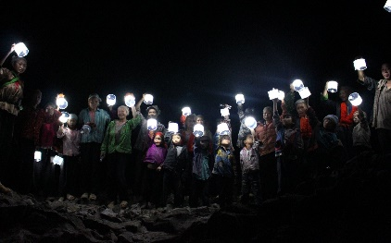
Your birthday and anniversary pennies are going to purchase Luci lights to help the people in Gaza during blackouts. And they are making a big difference in people’s lives!

Food Donations for August–201 pounds!
Food placed in the basket in the narthex is distributed to the Food Bank, the Rescue Mission or kept in the church office for people who fall between the cracks of services available. Food is weighed by our children on the first Sunday of each month. Our goal is to collect one hundred pounds of food each month.
Food Donations will be weighed on Sunday September 1st.

Submissions to the Messenger
If you have anything you would like included in the Messenger, please sent submissions directly to your friendly editor, Dan Dionne, at editor@firstumceureka.org. Note the new email address!

