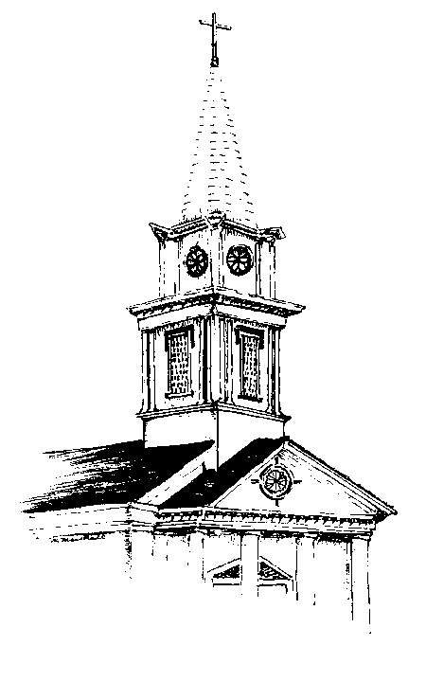
First United Methodist Church Non-Profit Org.
520 Del Norte U.S. Postage
Eureka, CA 95501 PAID
Permit No. 44
Eureka, CA

RETURN SERVICE REQUESTED
The Messenger

Eureka First
United Methodist Church

December 2019

Rev. Kathryn Dunning, Pastor Office (707) 442-3015 Pastor’s Cell: (707) 599-2295
Email: grace520@pacbell.net Website: firstumceureka.org

From Pastor Kathryn…
“Keep awake therefore, for you do not know on what day your Lord is coming.”
Matthew 36:42

Dear Ones,

Once again we are ready to begin a new Christian Year with the beginning of Advent on December 1. Advent is the season of 4 Sundays preceding the celebration of the birth of Jesus on December 25. Traditionally the scriptures read on each of those Sundays are about anticipation and waiting, but they are not about waiting for the birth of Jesus so much as they are about anticipating his return. Christians have had many and varied ways of interpreting what Jesus meant when he referred to coming back after his death, Resurrection and ascension. All four Gospels were written a generation or longer after the Resurrection and some scholars speculate that the reason it took so long for the events of Jesus’ life to be written down was because his followers thought his return was to be in their lifetime so therefore there was no need to record them.
When Jesus didn’t return in those first weeks, months and years after his physical presence had left the earth Christians started speculating when that would be, and some, despite multiple warnings in the scriptures not to, have predicted dates when that return would be. Myriads of those dates have come and gone. Billions of people have been born, lived their lives and died in the over 2000 years since Jesus birth, life, death and Resurrection.
Some Christians believe that Jesus has already returned, or never really left, because His Spirit resides in us all. And some belief that whether or not there is a physical return of Jesus to the earth, at our physical deaths we will see the coming of the Lord as we are received into the loving, eternal embrace of our God.
Christmas is when we celebrate God’s coming to earth in the form of Jesus, born just like you and me as a tiny helpless infant. Advent is the season of preparation and anticipation of what that event meant over 2000 years ago, and of “staying awake” in preparation for all the ways that God and Jesus will appear to us. Remember, none of us know when that “day. . . is coming.”
contact.

In Love,
Pastor Kathryn

Advent Bible Study
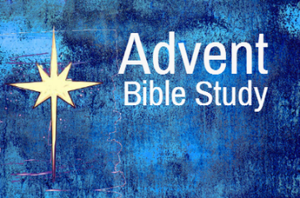
Pastor Kathryn will lead an Advent Bible study on Tuesday evenings at 7:00 PM and Wednesday mornings at 10:00 AM. For the three weeks prior to Christmas. This study will include scriptures from the Gospel of Matthew related to the birth of Jesus. The only book used in this study will be the Bible, and there will be no homework. This study will take place December 3rd and 4th; 10th and 11th,; 17th and 18th.

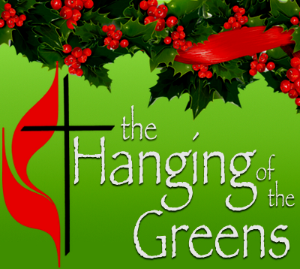
The first Sunday in Advent is December 1st, which we traditionally celebrate with “The Hanging of the Greens,” at Eureka First UMC.
Don’t miss this special Sunday as we decorate our church for the Advent season!

The Poinsettia Project
You are invited to donate to our Poinsettia “Project” in memory or honor of loved ones. A limited number of poinsettias are purchased to adorn our sanctuary during Advent. Remaining contributions will be used to replenish the “Pastor’s Relief Fund” which is a way of helping persons in need in our local community. Forms for this purpose are in the worship bulletins and can be placed in the offering plates through December 15 with a contribution of $8.00 per person being honored. If you have contributed to this project you may take a poinsettia home following the Christmas Eve service.

Christmas Eve Service
Come celebrate the birth of Jesus at our Christmas Eve service on Tuesday, December 24 at 7:30 PM with our traditional candlelight service.

Ending 2019 with a Praise Block Party
Once again Pastors Kathryn Dunning, Cassie Wyland (Eureka First Baptist) and Steve Berti (Eureka First Nazarene) are planning a “Praise Block Party” to be held at 10:30 AM at the Nazarene Church (corner of Humboldt and E Streets) on the last Sunday of the year, December 29 . We will share praise, worship and communion together as a way of ending 2019 and preparing for 2020.
Eureka First UMC will begin the morning at 9:30 in our sanctuary to share in a Wesley Covenant Service until 10:15, and then we will proceed to the Nazarene Church to join together there with our Baptist and Nazarene neighbors at 10:30. Don’t miss this opportunity for a meaningful and ecumenical ending to 2018.

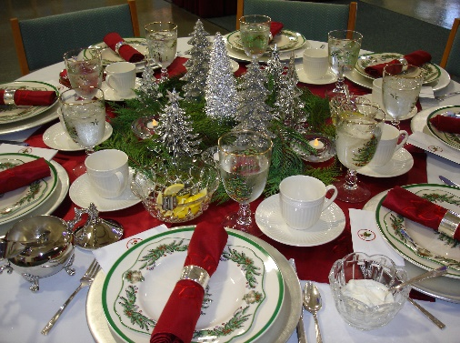
Eureka First United Methodist Church's 60th Annual Advent Tea!

The 60th Advent Tea will be held on Friday, December 6, 2019 at 1:00 pm. The Advent Program will be held in the EFUM Church. All are welcome! Following the Program a Tea will be held in Fellowship Hall. Reservations for the Tea are currently being taken. Please call the church office to make Reservations for the Tea. The Deadline for Tea Reservations is Friday November 22nd by Noon. A free-will offering opportunity will be available to benefit a community organization that helps others to see God at work. If you can be of assistance, particularly with cleanup, please contact Lori Green at 845-2927 or carol2624@sbcglobal.net

THANK YOU! To all the work day (plus) volunteers in November
Thank you to those who volunteered on our Second Saturday Work Day in November: Brad Johnson, Pam Coen, Robert Piasecki, Rob Dunning, Pastor Kathryn, Carol Dianich, Chad Rechelluul, Connie Wilson and Joan Brady. And look at all they accomplished outside and inside our buildings: pulled weeds, cleaned all shelves in the kitchen, finished trimming trees by Christie Hall, picked up trash, found lost items, painted top of cabinet in the hall near the kitchen, trimmed bushes by Sonoma Street walkway, put door stoppers on the fellowship hall door and sanctuary front door, cleaned bathroom fans, cleaned up a melted pumpkin, put up a sign by the accessible bathroom that had fallen down, helped the Bridge Club move to the fireside room, shopped for second Sunday breakfast, and fed the workers. THANK YOU!

Volunteer Opportunities

Second Sunday Breakfast Volunteers Needed
Our Second Sunday Breakfast will continue in December. The kitchen crew will be working hard to be sure that you can all enjoy a filling breakfast and some fellowship before service.
The kitchen crew would also like to seek and find a few more volunteers to help serve and clean up on our breakfast days. Please contact the church office or Pam Coen (707-496-4424)if you are being led to serve in this way.

Sound and Video opportunity Are you interested in learning something new? Do you want to have our own reserved seat in church? Do you want to give Brad a break from time to time? Consider becoming a part of the sound and video team. If you are interested in seeing what this is all about, please leave a message with the church office.

Sunday December 8th
SECOND SUNDAY BREAKFAST
8:00 a.m. to 9:30 a.m.
In Fellowship Hall
Everyone’s welcome!
Free will offering ($5 suggested donation) to cover expenses

Second Saturday Work Days
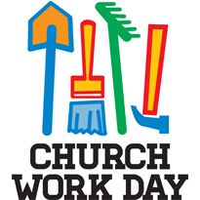
On Saturday, December 14, from 9:00 to 1:00, the Board of Trustees invites the whole church to come together to do the varied tasks of cleaning, sorting, and fixing that keep our church buildings and grounds in good shape. There are inside and outside tasks for everyone to do. Lunch is served to all the workers at noon.

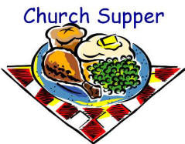
Third Saturday Supper!
On Saturday, December 21 at 5:30 PM you are all invited to Third Saturday Supper at Eureka First UMC. Dinner will be served at 5:30. The meal will conclude by 6:30 and be followed by cleanup by volunteers present and board games or other fellowship activities for those who wish to stay until 8 or 8:30. This will be a good time of food, faith and fun for all!

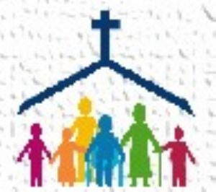
Church Family News

On Saturday, November 16, we celebrated the life of Ivan Leonard Agnew, Jr. who passed into God’s eternal embrace on October 24. Leonard joined Eureka First United Methodist Church at the age of 11 in 1945, and he and his wife Linnea raised their four children in this church.

Please hold the following persons in prayer:
Michele Montgomery, now under Hospice Care
Faith, 8 year old granddaughter of Brad Johnson, facing open heart surgery
Shirley Peterson
Don Quintrell facing hip surgery
Cookie Mahler
Hollie Klingel
Galeladi Runningbrook
Sadiki Koo’s
Herb and Sally Pierce
Sharon Warren
Neal Sligh
Gail Johnson
Silas Morrison
Jane Nelson’s 4 year old grandnephew, Rhett
Cory Cassevah, son of Sedona Bowser
Joshua Ruch, a young man dealing with depression.
Diane Mettam
Ralph Nelson
Aaron White and family
Bev Strubinger
Nancy Quintrell
Vis Upatisringa
Marty Johnson
Jonathan O’Keefe
The O’Keefe family
Wayne Palmrose
Mark McKinney
Irene Hedgecock
Irene Hedgecock

December Birthdays
1 Katie Quintrell 17 Marjorie Johnson
1 Carol Goodwyn 18 Tim Ryan
2 Kelby Ross 23 Travis Morgan
4 Beverly Strubinger 24 Ken Blackshear
6 Silas Morrison 25 Larry Johnson
7 Ginny Hedgecock 26 Jim Welsh
11 Thi Samelson 27 Lori Green
13 Hilda White 29 Heidi Quintrell
14 Margie O’Keefe 29 Liam Taylor
15 Pat Leahy 30 Bob Green
16 Glenn Cannon 31 Kellan Churchill
17 Ceilidh Powers
and anniversaries.....
December 17 Catherine & Michael Moore
December 22 Greg & Carol Goodwyn

Congratulations! -- If we missed your special day or have the incorrect date please call the church office so we can get it right next year.
♥ ♥ ♥ ♥ ♥
For our crafty members:

I have a large brown grocery bag full of mostly new, unused plastic needlepoint canvas free for the taking. Just give me a call and arrange to pick it up or I can bring it to church. Most sheets are white or clear, but some are in various colors. Just in time for Christmas crafting!

Diane Mettam, 441-9269

Financial Summary

November 2019
General Fund Revenue: $xxxxxx General Fund Expense: $xxxxxx

2019
2019 General Fund Revenue: $xxxxxx
2019 General Fund Expense: $xxxxxx
+- --xxxxxx

Thank you for your generous giving to God through the church.

November Worship Attendance
November 3 Total – xxx
November 10 Total – xxx
November 17 Total – xxx
November 24 Total – xxx

MUSIC AT EUREKA FIRST
Praise Band
Would you like to sing or play an instrument with the worship team? Join us for rehearsals on Tuesdays at 7 p.m.

After our performances for the Salvation Army and the Community Thanksgiving Sing, we are moving forward with our holiday music plans! We setting up our schedule for visiting Timber Ridge, Mad River Community Hospital, and bells alongside the Salvation Army ringers.

M I S S I O N S
If you have purchased gifts for Angel Tree Prison Ministries children, please bring the gifts to the church by Sunday, December 1.

Winter Clothing Collection
Louise Fredrickson is collecting jackets, gloves, scarves, hats, socks for the homeless to help keep them warm this winter. There is a basket in Wesley Chapel to collect donations. Please do not donate underwear or other items of clothing than the ones requested.

Thank you to Catherine Moore
Catherine Moore has been crocheting hats and scarves all year to give as gifts to those who are residents at Eureka Mission’s Women’s shelter during the Christmas season. At the November Third Saturday supper attendees wrapped over 45 sets for women in addition to the many Catherine had already wrapped for the children. That’s a lot of crocheting! Way to go Catherine!

DRUMM STICK SUNDAY 11/10
The Drumms are in South Asia! As their home church we raise funds to support their project. One Sunday a month we sell DRUMM STICKS (ice cream cones) -- $2 each. So, treat yourself to ice cream and support this exciting project.

New Recipient of Birthday and Anniversary Pennies
The Mission Committee has selected a new recipient for our birthday and anniversary pennies. Betty Chinn is opening a winter shelter and needs warm, washable blankets. The Committee has purchased some blankets to contribute from undesignated mission dollars, but there will be an ongoing need for more blankets and so that is what our birthday and anniversary pennies will purchase in the coming months.

CALLING ALL COOKIES!!

It has been a longstanding tradition at Eureka First United Methodist Church to deliver a plate of home baked Christmas cookies to our shut-ins and staff. Over the years we have explanded this outreach to include church members who live alone or need an extra bit of love and care. This yea, we want to also include the families of the children receiving gifts through the Angel Tree Project.
This means we need lots of cookies! You can participate by baking 2-3 dozen cookies and delivering them to the church kitchen on December 15 before church. You can also bring them by the church any time during the previous week. Just be sure they are labeled "for cookie day and stored in the fridge to protect them from ants (and larger nibblers). Last year, I was overwhelmed by this church's generosity and I thank you in advance.
--Angela Cameron

Cookie Santas Needed!!
We will be putting together the plates on Sunday morning and they will be be wrapped, ribboned and labeled with a name and address by the end of the service. If you could pick up one or several to be delivered during the next few days, it would be wonderful. The visit is often the best part of the gift. This is one small way we can remind people they are loved and not forgotten.

Food Donations for November–xxx pounds!
Food placed in the basket in the narthex is distributed to the Food Bank, the Rescue Mission or kept in the church office for people who fall between the cracks of services available. Food is weighed by our children on the first Sunday of each month. Our goal is to collect one hundred pounds of food each month.
Food Donations will be weighed on Sunday November November 3.

What's up with the Drumms?

Nikolas: I am learning to make enchiladas. I already know how to eat enchiladas (I am good at it!)

Tobias: I can play "Bare Necessities" almost all the way through on the piano. I can play faster when no one is listening.

Fabiola: I have been boxing at the gym with a friend. I love hitting the punching bag really hard. One of my older brothers boxed and used to let me use his gloves. Paul rolls his eyes.

Paul: With more translators to supervise and a growing interest in Peacemaker community groups, I spend more time traveling and away from home. I need to keep reminding myself that this is not an irritating bother but a gift of service.

Thought for the month
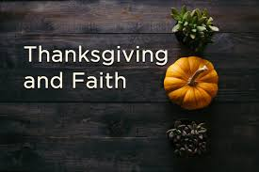
The Community Thanksgiving Sing is one of my favorite moments in the year. It’s not just the music; it’s really all about all the people of differing faith traditions coming together to celebrate their faith in the form of music. Every one of these faith traditions has something of value to share with all of us. The more we realize that we are many people but also one people, worshipping many ideas of the Deity but always the same Deity, the more we can understand and celebrate each other.

Submissions to the Messenger If you have anything you would like included in the Messenger, please sent submissions directly to your friendly editor, Dan Dionne, at editor@firsteurekaumc.org

