The Class Meeting

Chapter 1: A New (Old) Kind of Small Group
Key points:
Church vitality is directly correlated to small groups

What is a small group?
Types of groups:
- Affinity groups. Least effective.
- Information-driven groups. Not the most effective way to help people become mature Christians
- Transformation-driven groups. The most effective at making disciples, and churches should be invested in them

Addicted to Curriculum
Disciple as an example. “A major conviction of Disciple is that discipleship happens through studying the Bible.”
Curriculum can become addicting.
“But the Christian life is not primarilty about knowing the right things. It is about living in Christ.”
Doctrine is essential to know how to live. But it’s not actually living.

Class Meetings Promote Active Faith
Difference between active and passive postures. “Curriculum distances the participants from their own lives.“

The Goal of this Study
Quote from Nick Weatherford.

Discussion:
Name, how long in the church, why are you here?
General thoughts and responses. Strengths and weakness of the three types of groups. Which type do you have the most experience with? Do you agree with the transformation thesis?
Transformation Question: On a scale of 1 to 10 (1 being the farthest you have
ever felt from God, 10 being the closest you have ever
felt to God) what number would you give to how close
you feel to God today? Why?

Chapter 2: The Class Meeting: The Heart of the Methodist Revival
George Whitfield. “My people are a rope of sand.”
Statistics on growth of Methodism. “throughout the period of this growth, every Methodist was expected to participate in a weekly class meeting.” A strong case can be made that the class meeting was the
single most important factor to the growth of early Methodism
and to the retention of converts within Methodism. People who
had come to faith in Christ were immediately placed in a class
meeting, where they would be helped to grow in their faith and
where they would learn how to practice their faith.
From additional readings
John Wesley’s Class Meeting: A Model for Making Disciples
From his mother: emphasis on discipline and “method.” Susanna Wesley. Bookmark p. 27
Methodist groupings: societies. Bookmark p. 77

The Early Methodist Class Meeting” “Watching Over One Another in Love.”
Started as a fund-raiser in 1742.
The General Rules. The last one is to “attend upon the ordinances of God.”
To be a Methodist meant that you were involved in a weekly class meeting.
Details:
7-12 members
Mixed gender
Organized by location.
Three responsibilities: Held people accountable to keep the General Rules
Encourage to give weekly relief to the poor. Answer the question, “How is it with your soul?”
Not Bible or book studies.
Wesley felt that the class meeting was so important that he
believed that its decline would weaken Methodism itself. He
wrote, “Never omit meeting your Class or Band; never absent
yourself from any public meeting. These are the very sinews of our
Society; and whatever weakens, or tends to weaken, our regard
for these, or our exactness in attending them, strikes at the very
root of our community.”11

Organization:
:00–:15 Informal Conversation
Open with a Prayer
:15–1:00 Questions for Discussion
1. What were your general thoughts or reactions to
this chapter? Was anything particularly exciting or
challenging to you? Why?
2. This chapter suggests that one reason people
who came to faith in Jesus through Methodist
preaching persevered in their faith was because
they were organized into small groups. How could
your church do a better job of helping people grow
and mature in their faith?
3. Were you previously familiar with the class
meeting and its history in Methodism? Why do
you think the class meeting was so important to
early Methodist growth and discipleship?
4. What obstacles do you see that might make it difficult
for your church to return to a practice like the
early Methodist class meeting? How could these
obstacles be most effectively addressed?

Dan’s questions:
- Why did it succeed?
- Why did it drop out of favor?

THE DECLINE OF THE CLASS MEETING
CHARLES EDWARD WHITE
Looking back over the 170 years of existence of the Methodist Church
in 1909, historian Waddy Moss wrote:
Methodist has been faithful to its mission. That was defined by John Wesley as the
spread of Scriptural holiness; and amongst the most characteristic means he employed
was the gathering together of seriously minded people into classes for mutual help and
edification.'
He went on to predict:
Methodism will either retain her peculiarities (especially the class meeting) ...
or, ceasing to have a character of her own, she will range herself with the colourless
churches that are Christian institutions and answer a Christian purpose, but the co-existence
of which side by side can be defended on no sound principle of economy, efficiency,
or need.2

Causes for the decline, according to White:

- Harder to maintain discipline and standards as the denomination expanded
- The coming of the settled preacher
- Increasing wealth and social status of many Methodists
- a simplified and debased idea of conversion and growth. The most important part of Christianity was getting saved, and this experience as the greatest gift God gave to people in this life. Once they received it, it was their inalienable possession. No matter how they subsequently acted, bliss was to be theirs for eternity.
- The second major theological factor in the decline of the class meeting is the transition of Methodism from a society within Anglicanism to a church in its own right.
- A final theological factor in the decline of the class is liberalism. In both British and American Methodism during the 19th century there were changes in the doctrines of the Bible, hell, original sin, and Christian perfection. These changes moved the churches away from the Wesleyan positions and toward a more liberal theology.

1:00–1:15 Transformation Question
Describe a time when you felt closer to God as a result
of your participation in a small group. Or, describe a time when your faith was strengthened through an
interaction with another person (perhaps through
conversations, prayer, or Bible study with a pastor,
mentor, or friend).

Chapter 3: Moving into God’s House:
The Theological Foundation
of the Class Meeting
“Our main doctrines,
which include all the rest, are three, that of repentance, of faith,
and of holiness. The first of these we account, as it were, the
porch of religion; the next, the door; the third is religion itself.”3
The Porch: Repenting of Sin
The starting point for John Wesley was that people are in desperate
need of salvation and that we cannot save ourselves.
Faith: Entering into Salvation in Christ
Once we have recognized the reality of our situation before God
and have decided to turn away from the sin in our lives, having
stepped onto the porch of God’s house, what comes next?
After we recognize our need for salvation and our complete
inability to be the source of our salvation, we can turn away
from ourselves and turn to Christ in faith (and even this is only
possible by God’s grace). We can recognize the reality that God
has already done everything in Christ that needs to be done in
order for us to be forgiven of our sins and reconciled to God. The
theological term for the forgiveness of sins that comes through
Jesus Christ is justification
New Birth: Crossing the Threshold
of God’s House
Justification is by faith, and it is essentially the experience of being
forgiven of your past sins. But this experience is so profound that
it also leads to transformation. Forgiveness leads to a fresh start,
one that is so all-encompassing that it is properly seen as a “new
birth.”
Growth in Holiness: Moving All of Your Life
into God’s House
If repentance is the porch of God’s house, and faith is the door,
the new birth is when you cross the threshold of God’s house,
and holiness is the process of moving our lives completely into
God’s house. In one of his best-known sermons, John Wesley
put it this way, “At the same time that we are justified, yea, in
that very moment, sanctification begins.”1

The doctrine behind it all:
- Human nature is perfectible by God’s grace
- Learning comes by doing the will of God
- There is no holiness except social holiness
- The spirit and practice of ancient Christianity can and must be recaptured
- Human progress will occur if people participate in the “means of grace”
- The gospel must be presented to the poor
- Social evil is not to be resisted, but overcome with good.
- The primary function of spiritual/educational leadership is to equip others to lead and minister, not to perform the ministry personally
Henderson, 115-116.

Digression: ARMINIANISM VS CALVINISM
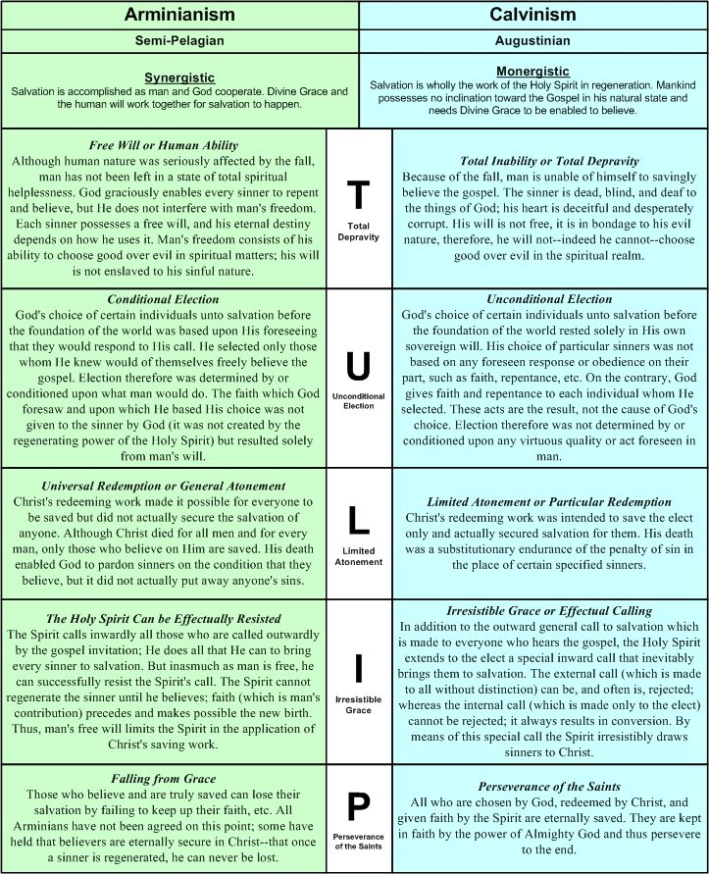

Jacobus Arminius (10 October 1560 – 19 October 1609), the Latinized name of Jakob Hermanszoon,^{[a]} was a Dutch theologian during the Protestant Reformation period whose views became the basis of Arminianism and the Dutch Remonstrant movement. He served from 1603 as professor in theology at the University of Leiden and wrote many books and treatises on theology. (Wikipedia)

The term "semi-Pelagianism", a 16th-century coinage, is considered a misnomer^{[4][5][6][7][8][9][10]} by scholars. Proposed alternatives include Massilianism, semi-Augustinianism, anti-Augustinianism, and antipredestinarianism. The historical theological dispute is also known as the Augustinian controversy.^{[11]} "Semi-Pelagianism" has frequently been used in a pejorative sense.^{[5][12][9]}
Organization:
:00–:15 Informal Conversation
Open with a Prayer
:15–:55 Questions for Discussion
1. What were your general thoughts or reactions to
this chapter? Was anything particularly exciting or
challenging to you? Why?
2. Which of these beliefs do you find easiest to affirm
or most central to being a Christian?
3. What ideas, if any, from this chapter were the most
difficult for you to follow or agree with? Why?
4. Do you agree with Wesley’s understanding of
Christian perfection? Are there legitimate reasons
that holiness, or deep obedience to Christ, is
impossible? If so, why?
:55-1:15 Transformation Question
Can you tell a story of when you (or someone you have
observed) stepped onto the porch of God’s house,
crossed the threshold into God’s house, or moved
your life more completely into God’s house?
Close with a Prayer

